Statement of Community Involvement
Millbrook Solar & Storage
Tom Berger · 15 June 2026 · MB-PLN-RPT-0006

1. Introduction
This Statement of Community Involvement (SCI) describes how Weyland Energy engaged with the local community and stakeholders before submitting the planning application for Millbrook Solar & Storage, what people told us and how the scheme changed as a result.

2. Our approach
We committed early to three public consultation events instead of the one event that is common for schemes of this size. The first two took place before submission; a third event on 16 September 2026 presented amendments in response to comments from statutory consultees. All events were advertised by a leaflet to 2,350 households within 3 km of the Site, in the Millbrook Gazette and on the project website. Millbrook Parish Council was briefed before each event.

3. Events and participation
Event | Date | Venue | Attendees | Responses
#1 | 2026-03-11 | Millbrook Village Hall | 164 | 97
#2 | 2026-05-20 | Millbrook Village Hall | 212 | 202

Responses combine paper feedback forms and the online form, which stayed open for three weeks after each event.

4. What we heard
Theme | Mentions #1 | Mentions #2
Glare for nearby homes | 38 | 61
Construction traffic on Mill Lane | 44 | 72
Skylark nesting habitat | 21 | 39
Visual impact from the public footpath | 35 | 47
BESS fire safety | 12 | 33
Loss of farmland / food production | 18 | 26
Flood risk on Mill Brook | 9 | 14
Community fund and local benefit | 15 | 41
Support for local clean energy | 31 | 68
Theme mentions in written responses (a response can raise several themes)
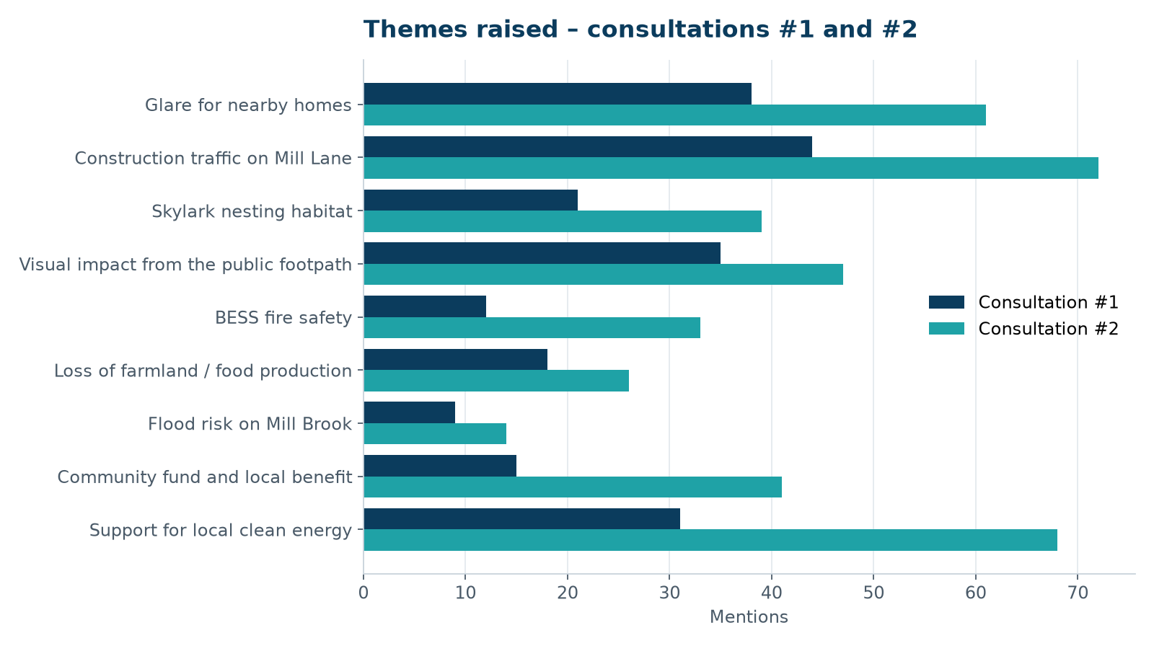
Most frequently raised themes, consultations #1 and #2

5. How the scheme changed
You said | We did
The panels will glare into our homes on Mill Lane. | Commissioned an independent glint and glare study; added a 3 m hedgerow screen at R04–R06 and kept a 50 m setback from Mill Lane.
Construction lorries will clog Mill Lane and pass the school. | Designed a temporary haul road from the B4127; no construction HGVs through the village section of Mill Lane; no deliveries during school drop-off and pick-up.
Skylarks nest in these fields every year. | Commissioned a breeding bird survey (23 territories); 46 skylark plots on retained arable land with five years of monitoring.
The footpath walk to the church will be ruined. | Widened the FP14 corridor from 15 m to 30 m and removed field 7 (5.6 MWp) from the layout.
What happens if the batteries catch fire? | Moved the BESS compound 420 m from the nearest home; outline Battery Safety Management Plan agreed with the fire and rescue service.
What does the village actually get? | Community fund of EUR 120,000 per year, managed by a local panel.

6. Ongoing engagement
A Community Liaison Group with the parish council, residents of Mill Lane and the primary school has met monthly since April 2026. Grace Mitchell (Community Liaison Officer) runs a drop-in at the village hall on the first Thursday of each month.

